Running “Hello World” on an OpenWRT Router

This guide will walk you through the steps needed to run code on an OpenWRT router by using an OpenWRT Build System.

# Prerequisites:

1. You will need a machine with a **linux distribution** as its Operating System (OS). This can be a virtual machine. For my build system, I used a virtual machine on VirtualBox using an OpenSUSE 15.0 OS. Here is a list of commonly used linux distributions

* Alpine
* Arch
* CentOS/Fedora
* Debian
* Ubuntu
* Gentoo

1. [Install git on your virtual machine](https://git-scm.com/book/en/v2/Getting-Started-Installing-Git).
2. Depending on your linux distribution, you will need to run some commands in a terminal to install the basic packages needed for the build system to work. They can all be found [here](https://openwrt.org/docs/guide-developer/build-system/install-buildsystem) at the bottom of the page. Here is the command I ran for OpenSUSE 15.0:

Source: (<https://openwrt.org/docs/guide-developer/build-system/install-buildsystem>)

# Part 1: Setting up an OpenWRT Build System

(Setting up the build system by cloning the source code)

Took an hour and 15 for me, could take less or more time, but be prepared to sit for a second.

In your home directory, create a folder (the name is arbitrary, but for this tutorial we are using “buildroot”) to hold the source code from git. In the terminal, enter the following commands:

cd ~/buildroot

git clone https://git.openwrt.org/openwrt/openwrt.git source

cd source

At this point, the git repository code should be contained within a folder called source, and your current directory is ~/buildroot/source

Next, run the following commands.

***Please note that “openwrt-19.07” is the name of the latest stable git branch for the source repository (as of October 2020). If you are viewing this at a later date,*** [***go to this link***](https://git.openwrt.org/openwrt/openwrt.git) ***and look at the section that says “head” and pick the most recent branch. Here is a picture of what that should look like:***

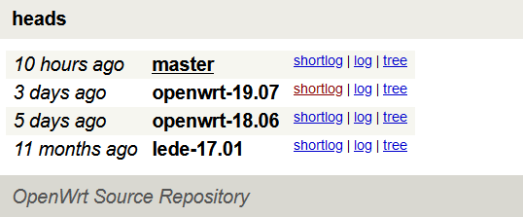

git checkout openwrt-19.07

make distclean

It is recommended that you update and install your 'feeds' packages to avoid future problems. You can do that by entering the following commands:

./scripts/feeds update -a

./scripts/feeds install -a

Now you configure the cross-compilation tool chain with the graphical configuration menu.

On the menu select values for ‘Target System’, ‘Subtarget’, and ‘Target Profile’

Because my OpenWRT router is on my virtual box as another machine, I configured it with the following values:

* Target System: x86
* Subtarget: x86-x64
* Target Profile: Generic

The configurations will look different based on what type of router you have!

Save and Exit the menu

Now build the target-independent tools and the cross-compilation toolchain by running this command in your terminal

make toolchain/install

**Buckle up! This might take a while. It took me about 75 minutes…**

The last thing to do to prepare your build system is to adjust the path variable!

Run the following command:

export PATH=/home/deyo2303/buildroot/source/staging_dir/host/bin:$PATH

# Part 2: Saying Hello World!

Make a directory for your source code in your build root folder and then change your current directory to it by running these commands:

cd ~/buildroot

mkdir helloworld

cd helloworld

Create and edit your source code file by entering the following command and then opening the file in a text editor.

touch helloworld.c

Here is an example Hello World application. You should write something similar in your helloworld.c file

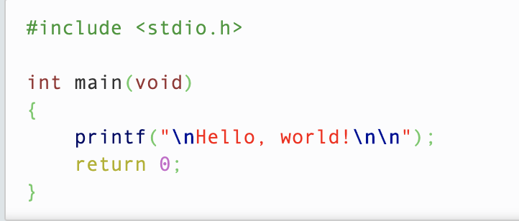

Once you have saved the code, compile and link the application by entering the following commands:

gcc -c -o helloworld.o helloworld.c -Wall

gcc -o helloworld helloworld.o

Test the code by running the following command:

./helloworld

Source (<https://openwrt.org/docs/guide-developer/helloworld/chapter2>)

# Part 3: Creating a Package and Making it Available For Firmware Configuration

Note: Anytime you see ~/buildroot… or /home/deyo2303/buildroot… please replace with the path in your corresponding file structure if the names are different

## Creating a New Package:

In your “buildroot” folder, run the following commands:

mkdir -p mypackages/examples/helloworld

cd mypackages/examples/helloworld

Now you can create the package manifest file. In a OpenWRT build system, every package has a manifest file that describes what the package does and provides instructions on how to obtain the source code of the application.

Run the following command:

touch Makefile

Open up this new file and copy paste the Makefile from [this link](https://openwrt.org/docs/guide-developer/helloworld/chapter3)

After copy and pasting, you will need to:

* change the source directory in the file to the path of your helloworld file (/home/deyo2303/buildroot/helloworld)
* change the spaces one every line starting with a large amount of spaces (8 spaces), to a single tab

Source 1 (<https://openwrt.org/docs/guide-developer/helloworld/chapter3>)

## Make the Package Available for Firmware Configuration!

The OpenWRT build system uses a file called “feeds.conf” to indicate which packet feeds are available for firmware configuration. You will need to create this file by entering the following commands:

cd /home/deyo2303/buildroot/source

touch feeds.conf

Open up feeds.conf in a text-editor and enter the following line

src-link mypackages /home/deyo2303/buildroot/mypackages

Save and close the file and run the following commands:

cd /home/deyo2303/buildroot/source

./scripts/feeds update mypackages

./scripts/feeds install -a -p mypackages

If this is successful, you should see a response in the terminal like “Installing package ‘helloworld’ from mypackages”. **If you DO NOT see this, check that the path you put in your feeds.conf and your package manifest files are correct.**

Source 2 (<https://openwrt.org/docs/guide-developer/helloworld/chapter4>)

# Part 4: Build and Deploy your Package!

## Build your Package

From the source folder, run:

make menuconfig

From the GUI that pops up:

1. scroll down to the examples menu and press enter
2. highlight the package called “helloworld” and press y. You should see a star next to it now
3. use the right arrow key until you are over “save”
4. press enter and follow the menus to save your configuration (save to the default .config file)
5. use the left arrow key until you are over “exit”
6. exit until you close the GUI

Now, run the following command:

make package/helloworld/compile

If you are successful you should see a package called **helloworld_1.0-1_<target>.ipk** in your **/source/bin/packages/<target>/mypackages** folder

You are now ready to deploy the package on your router! The router I used is a x84_64 Linux OpenWRT router setup on VirtualBox.

You can just SCP from your development machine to your router. For example, with both machines on and open I entered the following commands:

cd source/bin/packages/x86_x64/mypackages

scp helloworld_1.0-1_x86_x64.ipk root@192.168.56.2:/tmp

These commands securely copy the package from my development machine, to the router’s tmp directory.

Now, on the router you can check the tmp directory to see if the package is there by entering the following command:

cd /tmp

cd ..

You should now be able to run the following commands to install and test your helloworld application!

opkg install /tmp/helloworld_1.0-1_x86_x64.ipk

helloworld

Source (<https://openwrt.org/docs/guide-developer/helloworld/chapter5>)